|  |
| --- |
|  |

|  |
| --- |
| GROUP-B  Members: Harry Su, Min, Angy & Harry Liu  User: Group D |

|  |  |
| --- | --- |
| Documentation for GroupB |  |



Preliminary IPT AT2

Documentation

|  |
| --- |
| UNDERSTANDING THE PROBLEM |

|  |  |  |
| --- | --- | --- |
| Requirement Report The needs of the users when viewing the website is to obtain product information that are relevant to them such as description and purpose of the item, instructions, examples of work and purchase details (price, collections, bundles). Since the product it is still in development, users may be interested in the product development timeline and be informed about official release.  Collecting data from NEXMAP website and the Kickstarter page such as item description, pricing, product progression etc. Processing the data into appropriate, necessary information for the website subpages and in the perspective of the group promoting the product. Stores the information in a word document and extracted when the website framework is established. Displaying the information gathered and place onto the website for end-users to view. | | |
| The data/information of the system include the names of developers of both the website and product, the cost of product, images provided by the developers of the product, description of product and what it entails. A video source is available with content that is designed primarily to introduce the product and create interest in investing in the product for the end-users. Other provided information such as contact details in case of users and participants’ need to contact the developers for issues such as accreditation concerns. | | |
| he users and participants of the program is the developers who creates the website, the original owners and Kickstarter the product and their contribution of production information. The end-user which is assigned by the teacher that views and evaluate websites criteria of success. |  | The available information technology needed for the development of the program includes a computer to access all necessary software such as Adobe Dreamweaver, InDesign, photoshop etc. |

|  |
| --- |
| PLANNING |

|  |  |
| --- | --- |
| **Explain how you will meet each of these needs**   * The needs stated above can be met by reading over the campaign website Kickstarter and NEXMAP the official website where the creators post information for both retailers and businesses and consumers. From there we could extract the data/information that satisfies the needs of users such as description, cost and value.   **Explain what Info Tech needs to be provided**   * A desktop/laptop with the required software and has the capabilities to handle and process the work done. * Some sort of cloud sharing software that allows files and progress to be shared and recorded for every member of the group.   **“*If you fail to plan, then you plan to fail*”** |  |
|  |

Roles

|  |  |
| --- | --- |
| Member | Roles/Skills |
| Angy | * InDesign: Infographic * Context Diagram * Pamphlet |
| Harry Liu | * Website Information * Background Research * Filler Text |
| Harry Su | * Documentation * HTML and CSS coding |
| Min | * Documentation * HTML and CSS coding * Level 1 DFD |

Designing

Context Diagram:

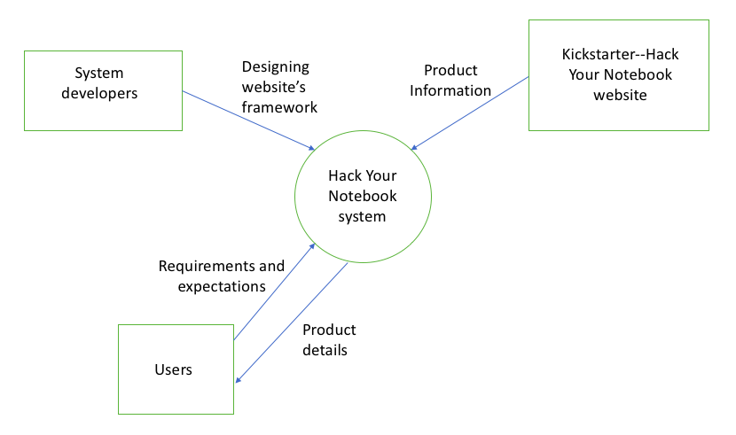

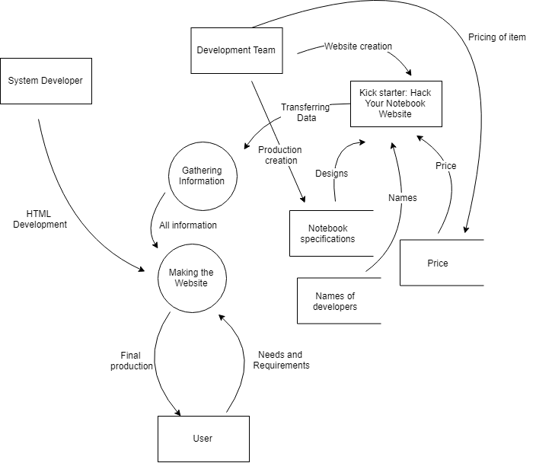Level 1 DFD Diagram

Gantt Chart

The logbook, research and idea generation is the first stages that will be executed before moving onto the other stages.

The logbook is to be maintained throughout the project.

Evaluation is to be done a week or a few lessons prior to the end of the project.

Idea generation is to be managed as soon as possible to therefore allow for planning of design to be conducted within the first 2 weeks of receiving the project.

Sourcing information must be done early according to this time management plan to allow for ample time to correct errors.

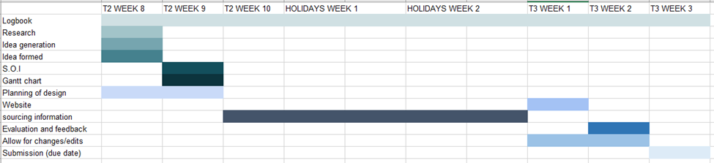

The gantt chart is only a guide, unexpected events may cause problems that disrupt this time plan. The deadlines however should be followed so regardless of the situation efforts can be made to realign or move the project back on schedule.

Infographic

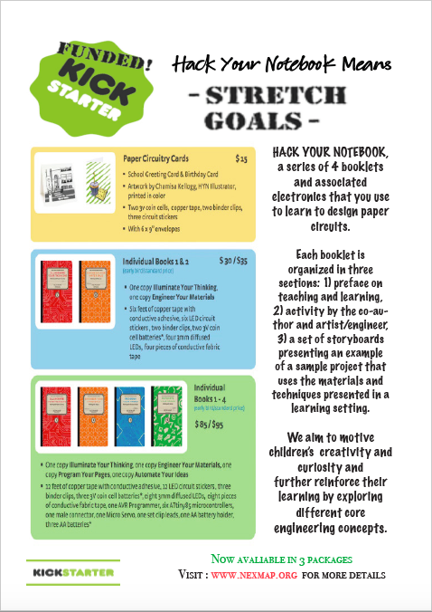

Pamphlets

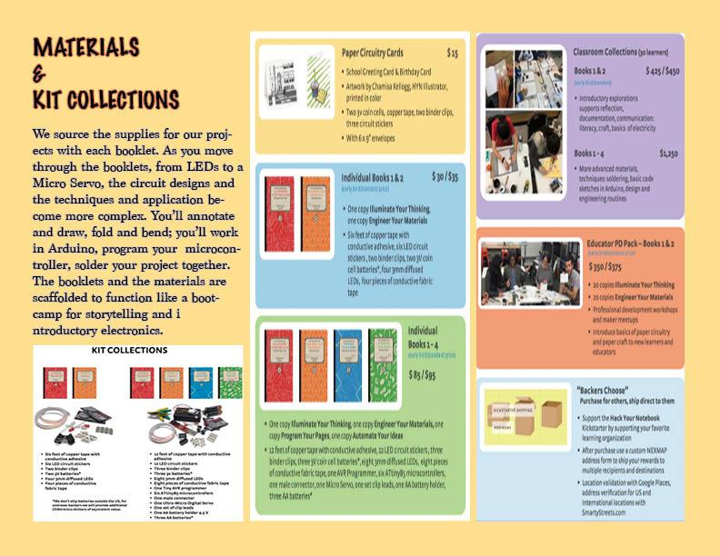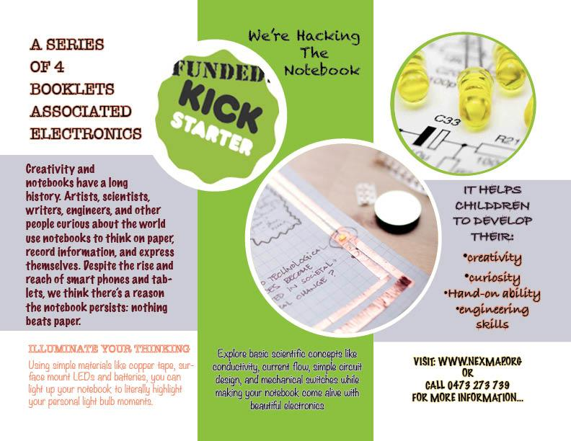

Storyboard

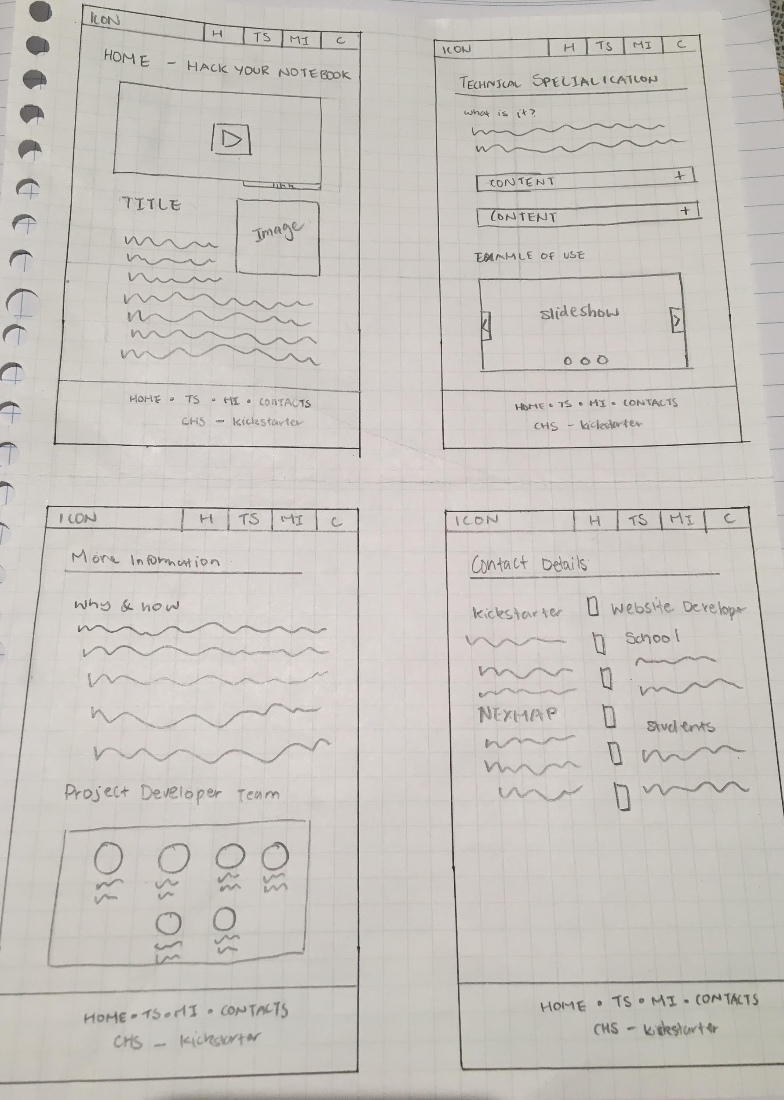For website:

Development

List of development tools:

- Google drive

- Google docs

- GitHub

- Adobe Dreamweaver

- Adobe InDesign

- Adobe Photoshop

Google Drive:

Cloud based software that manages and stores many files.

Google Docs:

Cloud based word processor where multiple people can edit and contribute on documents.

GitHub:

Online cloud-based system that allows for better project and file management for website, and application developers.

Adobe Suite:

Applications that allow the group to edit and create graphics and code a website.

Hardware/software operating environment:

- School

- home

Main features of the digital media components:

- Text font

- Graphic type/resolution

- Images

- video

Logbook

Log book

The project was suspended over the winter holiday break in July. As a result, subsequently to this date no further progress has been made. Work has commenced on 24/07/2018

24JUL2018:

During this lesson we commenced work on the project, and allocated roles and taskings. Min will by the end of this lesson complete a framework for the website, Harry will have researched marketing for the website and Angy will have completed a Context Diagram for the system. Su will complete a Gantt chart and document the relevant information in a presentable format. Min will also make a Data Flow Diagram (Level 1).

The actual Gantt chart will be completed as development of the project goes. This will be concurrent with the logbook. Any events logged will be reflected on the Gantt chart.

26JUL2018:

During this period, we started to do work on the actual website development with Min working on the website storyboard for the four web pages: home, contacts, more information, TS. Angy made the draft for the infographic separating the page into subheadings and set the basic layout of the page uses _Adobe InDesign_(add software). Harry Liu was assigned to research the content that needs to be included into the websites with different pages.

27JUL2018:

Following along the website storyboard made the day before, Min made the basic framework, adding a navigation bar from W3 school and linked each page together. Created a margin base used throughout the pages for consistency. Incorporated the information gathered by harry Liu from yesterday under the tag <p>. Added elements such as images, video, slideshows, collapse tabs, double column structure. Angy started making the infographic adding information gained from the Kickstarter website.

30JUL2018:

Min continued working on the implementation of the website creator a basic footer with a placeholder colour to differentiate the background colour. Min also reformatted the webpages and attempted to add a icon in the navigation bar. Angy incorporated images in the infographic to fill up the empty spaces and making the infographic more engaging. Finished the infographic by the end of class.

03AUG2018:

For this lesson, Min and Harry swapped roles with documentation and the website coding. Min completed the requirement report, the series of questions asked in the planning stage and continued with adding logbook entries. Angy started with a paper draft version of the pamphlet for both sides.

06AUG2018

With the pamphlet draft made a few days ago, Angy was implementing the digital media using InDesign. Harry liu was re-assigned to search and provide the necessary information for the websites since the content given was in-efficient. Min had to re-draw a storyboard for the website since the previous one was lost. Harry Su finished formatting home page and contacts page.

08AUG2018

Harry Su has completed all the HTML and CSS for the official website framework and Angy has completed the double-sided pamphlet. Finished answering questions for designing stage.

09AUG2018

Every member in the group has completed with writing individual evaluations, ready to be submitted. Website is officially completed with full functionality for the end-users to view and navigate. Completed all necessary documentation.

10AUG2018

Have the end-user group to evaluate the website and rate us out of 5 marks. Finish writing group evaluation. Submitted work by Min and Harry Su.

Ethical Concerns

A minor ethical concern that plagued our group was the fact that the assignment required us to copy information and data from a pre-copyrighted project on Kickstarter.

Stealing from entrepreneurs, was the last thing anyone in our group wanted to do. Especially seeing as the project’s main goal was to code and develop a website.

The concern was raised in class, to get around this, we are covered and protected if we acknowledge and declare that this is not a representation of the product and ensure that the website remains unpublished to prevent copyright infringement.

The reason for this is based on educational grounds. Therefore, should any problems arise it can be pardoned as the copyright infringement would be invalid.

Research

Hack your notebook is a series of 4 booklets and associated electronics that people use to learn to design paper circuits. The purpose of this project is to get introductory design and engineering experiences to more kids and teachers with a low-cost technology to know “wide wall” learning experience. The materials and practices reflect deep craft traditions, the iterative approach in the scientific method, and a transformational mindset for teaching and learning in the 21st century.

21c Material and Kit collections.

info: The basic Notebook hack Each kit provides materials for 20 makers and includes the following:

* 240 LED Circuit Stickers: 120 RYG, 120 White (12 per hacker) from Chibitronics
* 1 roll of 1/8" copper tape with conductive adhesive
* 1 roll of 1/4"" copper tape with conductive adhesive
* 20-3V coin batteries
* 20 sewable coin battery holders
* 40 alligator clip test leads
* 5 needle threaders
* Multicolored crochet thread for custom leads
* 1 spool of conductive thread for custom leads (400 ft.)
* 4 crochet hooks
* Educator orientation letter with a list of online resources including activity cards, instructions and design challenge cards for download

“NEXMAP”

It builds future- ready teachers and learners at the intersection literacy, craft, technology, and open data. Transformational hands on learning, introductory electronics, and civic engagement, allowing learners to explore circuit for using local data to build essential literacies that connect people to each other and their communities.

Focused on leadership development and the use of public data as part of an emerging civic infrastructure for teaching and learning, Hack Your Notebook and Open Data/Open Minds present paper and electronics as a learning platform for educators in and out-of-school that targets engineering, storytelling, physical computing, and data literacy.

Idea of hack your notebook

info : ( The idea for Hack Your Notebook came from a random encounter that David Cole ofCV2 and Jennifer DickNextmap, an *Educator Innovator* partner, had withJIe Qie, a doctoral student at theMIT media lab who focuses on blending electronics with traditional arts and crafts).

Take your notebook to the next level by adding a dedicated battery and built- in power leads. Illuminate thinking and highlight best ideas with circuit stickers LEDs. people also can share what they made with the larger community of notebook hackers on google group or Twitter.

Filler text

About ：Kickstarter

Kickstarter helps artists, musicians, filmmaker’s designers, and other support they need to make their ideas a reality. It is an enormous global community built around creativity and creative projects. Over 10 million people from every continent on earth, have backed a Kickstarter project.

Product: 1. Paper Circuitry Card（$ 19): School Greeting Card & Birthday card, Two 3v coin cells, copper tape, two binder clips.

With 6 x 9 envelopes.

2. Individual Books 1&2 ($45/ 50)

One copy for illuminate your thinking

Other for Engineering your materials.

Six feet of copper tape with conductive adhesive, six LED circuit

3. Individual Books 1-4 ($100/$105)

Illuminate your thinking. Other engineer your materials, one copy program page. Last copy Automate people’s ideas.

4. Educator PD pack- Book 1 & 2

$ 450/ 475

Introduce basics of paper circuitry and paper craft to new learners and educators.

13 feet of copper tape with conductive adhesive, 14 LED circuit stickers.

Contact : mobile:(61) 450 888 667 (02) 135 7080667 email/ kickstarter@gmail.com

Location: 7/4 Martin Pl, Sydney NSW 2000

Group Evaluation:

After strenuous debate amongst the group members it was decided that the project was a terrible failure. The project’s initial time plan was not followed by all members as a result the distribution of work was inadequate and unfair.

Work was placed on members who contributed however did not excel in those fields. As a result, placed unnecessary stress on them, reducing the quality and the work pace.

In future members need to actually stick to the time plan or make some form of effort to stick to such a vital plan to prevent a similar outcome to this.